REPORT – Corryong Primary School Site Community Consultation

February 2022

Introduction
The Corryong Primary School site consultation project was initiated in 2021 at the request of the Corryong and Upper Murray Community Recovery Committees (CRCs). The CRCs were keen to have the project independently facilitated by Bushfire Recovery Victoria (BRV). BRV agreed to lead the project with the support of a steering group comprising of representatives from the two CRCs and Towong Shire Council.
This report outlines the results from the consultation project. Completion of the consultation report finalises BRV’s involvement in the Corryong Primary School Site project.

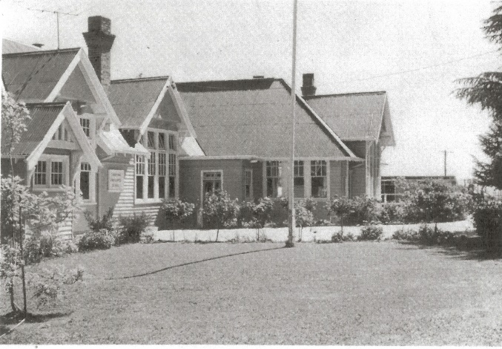
Background
Information from the Upper Murray Historical Society Inc provides a picture of the vibrant history of the Corryong Primary School campus. The campus opened in July 1877 and was locally referred to as the Corryong Upper Murray High School. Originally built with just one large classroom and residence, over the next thirty years the number of students increased and additional rooms were added to the site.
By 1953 the campus had become a Higher Elementary School and was split into two campuses with Primary and Secondary school on separate sites. In 1958 the school was recognised as a Consolidated School, this occurred with the closing of all the smaller outlying schools in the Upper Murray and children began to catch a bus to attend school in Corryong. It was around this time that the Nariel School Building was also brought to the site and used as the arts and craft room.
With the arrival of the Snowy Mountain scheme in the 1960s the number of students dramatically increased. In the 1980s the administration building was also added to the site. In April 2002 Corryong Consolidated School and Corryong Secondary College merged to become Corryong College, a P – 12 school. In February 2020, the junior campus closed and a P - 4 building on the senior campus now provides a modern learning environment.
The old primary school building is of high significance to the community both historically and sentimentally. It provides an opportunity for development to enhance the amenity and growth of the Upper Murray.
Before the relocation, Upper Murray Inc and a number of keen community members began to advocate for a determination of the future of the disused site. Following the Black Summer Bushfire, resolution of the future of the site was considered a priority to rebuild community confidence in an optimistic future for the Upper Murray community.
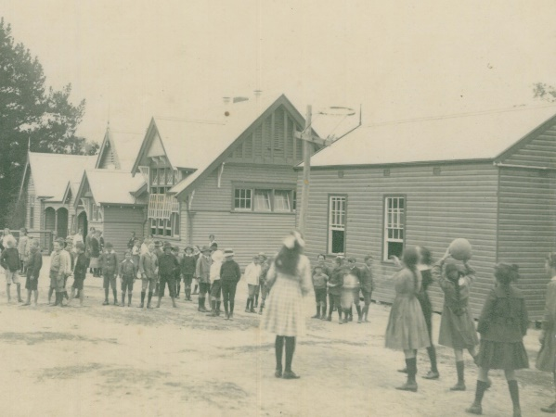
In February 2021, the Corryong and Upper Murray CRCs approached Bushfire Recovery Victoria (BRV) to coordinate a community consultation project to document community aspirations for the site.
BRV agreed to coordinate the consultation project on behalf of the CRCs with both CRCs participating in a project steering group, along with a Towong Shire Council representative. The project aimed to produce a consultation report to be presented to Council as an evidence base of community aspirations for the site.

Context
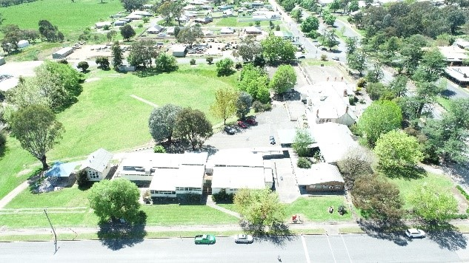
The disused primary school site covers a substantial area on the corner of Donaldson and Towong Road in Corryong. The site adjoins the main street and includes the original Corryong Primary School building, a construction of significant historical interest. The site also includes a number of other permanent and demountable buildings in varying states of repair. There is a large recreation oval, disused netball courts, a partly covered children’s playground and large toilet block.
In early 2021 Towong Shire Council was granted approval from the Victorian Department of Education for use of the site as a Bushfire Recovery Hub. Considerable renovations were undertaken on the former library building and toilet amenity to meet the Recovery Hub needs. A second building was made available to Grocon to coordinate the local bushfire recovery building clean up program. Space was also made available for a community run relief centre, providing space for collection and distribution of donated items.
The site contains the historic Nariel Valley school house which had been relocated to Corryong some years earlier. The Nariel Valley school house was not included in the scope of the project, as the Nariel Valley community are currently investigating the feasibility of relocating the asset back to the Nariel Valley.

Process
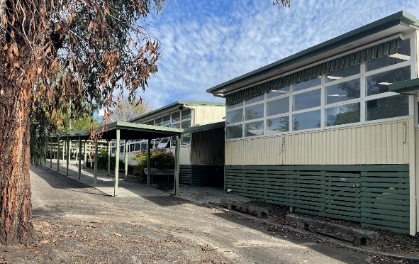
In collaboration with the steering group, BRV contracted a consultant in July 2021 to implement a comprehensive community consultation and capacity building project. In September 2021, the consultant advised BRV that it did not have the capacity to deliver the project within required timelines and withdrew from the project. The Steering Group then developed a new project plan, utilising resources available through Towong Shire Council and the BRV Community Recovery Support Panel, aiming to complete the project by December 2021.
The consultation plan was based on three key elements:
- Comprehensive survey (online and hard copy) to determine community connection to the historical school building and identify community aspirations for the future of the site.
- Focus groups to target high interest community cohorts to dive deeper into community aspirations.
- A community workshop to test outcomes from the two consultation activities and ensure analysis outcomes genuinely reflected community sentiment. The workshop also aimed to understand community priorities for future development of the site.
The project was supported through the development of a project website via the BRV Digital Engagement Platform. The platform provided an avenue to collate survey responses, as well as promote images and stories related to the project.
BRV contracted The Community Entrepreneur to implement and report on the focus group series. The BRV Digital Engagement Team collaborated with the Steering Group on development, implementation, and analysis of the survey. Towong Shire Council engaged Susan Benedyka Consulting to facilitate the community workshop. The BRV Northeast Community Engagement Team developed the final project report on behalf of the Steering Group.
The consultation report finalises BRV involvement in the project. Towong Shire Council and the Upper Murray community will continue planning and advocacy activities towards realising the community’s vision for the site.

Consultation outcomes
The overall consultation outcome was clear and consistent – there is a very strong desire for the primary school building to be kept and repurposed for community use. The community strongly supports the site being retained as a multi-disciplinary community space, most strongly suggesting the inclusion of community recreation (41%), early education and services (39%), and tourism attractions/services (24%). Art and Culture (12%) and Higher Education (12%) also received a strong response.
In the community survey, youth recreation was categorised under community recreation space, which came through as a clear priority. Many responses highlighted that there needed to be a space for youth activities like sporting facilities, pump bike track, parks, skate park.
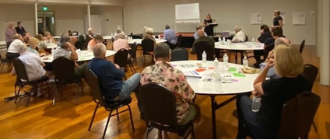
91% of survey respondents indicated that the historic building should be retained, respectfully restored, and used for community benefit. When asked what part of the site should be retained, respondents answered:
- The historically significant building (64%)
- The oval area (44%)
- The buildings along Hanson Street frontage (31%)
- All buildings (28%)

There were some queries associated with this response, raising questions regarding cost, maintenance, and governance arrangements if the building were to remain a community asset. The community workshop raised concepts for respecting the historical significance of the building without retaining the entire physical building. Further community consultation to gain a deeper understanding of the community’s limits in terms of acceptance of financial and volunteer impacts is highly recommended.
The focus groups further reflected the community’s vision for retaining the site as a multipurpose asset. There was a clear desire to keep the space for community benefit and not to introduce external retail chains.
Thirty community members participated in the community workshop. As participants moved through the agenda, a sense of shared vision for the site became clear. Negotiables and non-negotiables in relation to the site were agreed. In summary, key negotiables were generally related to the arrangement of services and facilities on the site – if open green space was retained. Clearly non-negotiable to the community was that the site be retained for multi-purpose community use to benefit community across the life span. Respect for the heritage value of the old school building was also vital.
The workshop also identified critical criteria that the community believe should be prioritised regarding future development of the site:
- Community benefit – any development on the site should address an evidence-based community need.
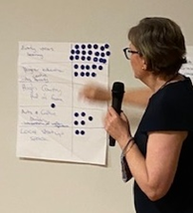
- Sustainable – the costs involved with development and ongoing governance and maintenance should be carefully considered in view of community capacity in terms of financial impact and volunteering needs.
- Multipurpose – the site should be developed for whole of community benefit and consider multi-generational services and attractors.
- Management / maintenance - governance arrangements for any future development should consider community input, while minimising impact on community capacity.
- Supports future growth and planning – developments should add value to the existing culture of the Corryong community and not detract from or replicate existing services or businesses.
- Supports community/people/families – any development should be accessible to all of the community.
- Non-exclusive – available and welcoming to all. Future development should consider existing and future population growth and demographic nature of the community, including physical, cultural and socio-economic accessibility.

Conclusion
The consultation project resulted in a clear and consistent community vision for the site.
The community is strongly attached to the historical school building and request it to be incorporated into future development. There is scope for further consultation to understand financial and volunteer impacts in regard to the retention and ongoing upkeep of the building, and the community’s limits in terms of managing these costs.
The community expressed a clear desire for the site to be retained for community use. The community wishes to see multi-purpose services developed on the site that support families and individuals across the life span. The site should retain open green space for passive and active recreation. There was keen interest in retaining the toilet amenity as an important public asset for the eastern end of the main street. Support was also high for inclusion of botanical gardens on the site.
The community proposed a number of service options with significant support for early years health and education. Interest in tertiary education services such as a school for agricultural training gained strong interest. The community would not like to see the site used for retail chain outlets or industrial development, however are open to the inclusion of art and cultural activities and the potential for inclusion of short term business rental spaces and accommodation options for older community members.
The community expressed strong interest in the next steps in achieving their vision for the site. There is a general lack of community understanding of the process and timeframe involved in advocating for the future of the site, providing Council an opportunity to continue engagement with the community and building community capacity to advocate alongside Council toward their vision.

Attachments:
Report – Survey Analysis – Corryong Primary School Site
Report – Focus Groups – Corryong Primary School Site
Report – Community Workshop – Corryong Primary School Site
