Report - Community Workshop

16 February 2022

Corryong Primary School Site - Community Aspirations

# Summary

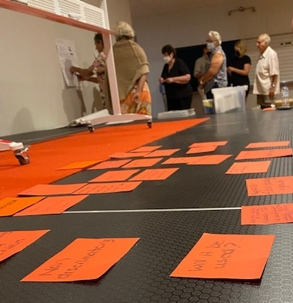The Corryong Primary School community workshop was attended by 31 community members from across the Corryong district. The event was led by professional facilitator, Susan Benedyka, supported by BRV Community Engagement Facilitator (Tracey Farrant), BRV Community Liaison Officer (Janelle Gibson), and Towong Shire Council Manager Recovery and Relief (Jenelle Williamson).

The workshop strongly confirmed the community desire for the site to be retained for multi-purpose use to benefit community across the life span. Maintaining green space and respecting the heritage value of the old school building was also vital.

Outcomes from the workshop, along with the results of other consultation activities, will be collated into a report to be presented to Towong Shire Council by June 2022. Completion of the consultation report finalises BRV’s involvement in the Corryong Primary School Site project.

# Introduction

In February 2021, the Corryong Community Recovery Committee (CRC) approached Bushfire Recovery Victoria (BRV) to coordinate a community consultation project to ascertain community aspirations for the site. A consultation program was co-designed with the Corryong CRC, Upper Murray CRC, and Towong Shire Council. The consultation project was based on 3 key phases:

1. A comprehensive community survey: online and hardcopy to identify general community aspirations for the site.
2. A series of 5 focus groups to identify the aspirations of cohorts with a high interest in the site.
3. A community workshop to check the validity of survey and workshop outcomes and prioritise aspirations.

The community workshop was widely promoted in print and social media and through community networks.

The workshop aimed to test results of the previous community survey and focus series to ensure that interpretation of the results resonated with the community.

# Context

The community workshop was the final element in a three-phase consultation approach. An extensive community survey and series of targeted focus groups were held over October to November 2021. The community workshop was originally planned for December 2021. COVID-19 impacts led to postponement of the event until February 2022. The workshop was widely promoted during the postponement, resulting in strong attendance.

The community survey provided the key foundation for ascertaining community ideas and preferences for the site. Focus group outcomes reflected the survey results and provided more nuanced information from specific cohorts.

**Key survey outcomes**

The survey strongly indicated community interest in retaining the site and preserving the historically significant original school building.

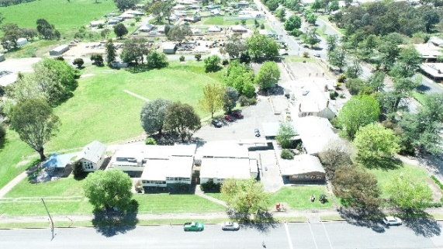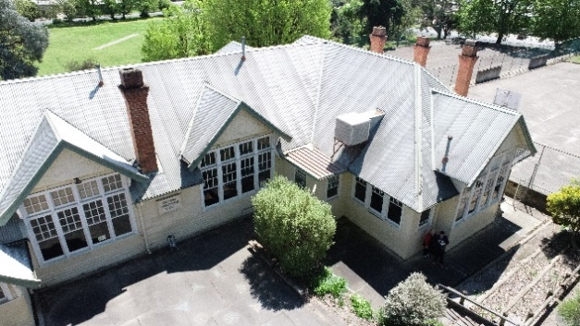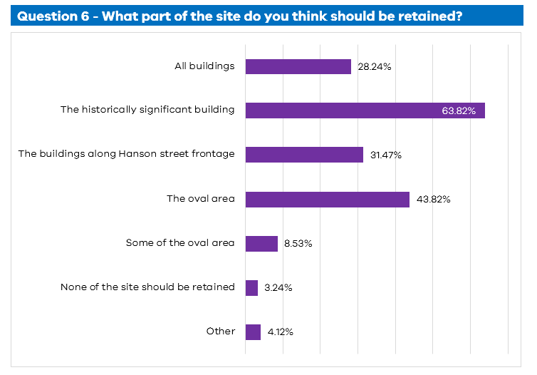

Analysis identified 10 clear themes that the community was interested in for the site.

|  |  |
| --- | --- |
| Category | **Examples referenced** |
| Early education & services | Multi-disciplinary early years learning centre; before/after school care; kinder/playgroup; holiday programs; maternal child health services |
| Housing & Accommodation | Rentable space; short term accommodation; residential housing |
| Retail & Hospitality | Retail; food & hospitality; local café; brewery |
| Higher Education | Adult education; outdoor education & training camp; agriculture school |
| Community recreation space | Youth recreation*; exercise equipment; gardens; community gathering space; sport; green space; maze; sculptures; summer BBQs; library; park; nursery  *Youth recreation was a strong theme. Examples for youth recreation included: kids BMX track, bike pump track, skatepark, basketball, cricket nets |
| Tourism | Tourism services; tourism attraction; caravan/RV park; camp site; Man from Snowy River attraction; hall of fame |
| Allied Health | Disability services; mental health services; youth services; osteopaths/occupational therapy services etc |
| Public Amenities | Parking; restrooms |
| Art & Culture | Markets; festival/event space; art classes; workshops; arts centre; theatre; studios |
| Independent & Assisted Living | Independent living facility; aged care housing; aged care services; respite services |

**Key focus group outcomes**

Five focus groups were held to discuss the future use of the disused Corryong Primary School site.

The focus groups comprised:

1. Young families - Six women who attend the Maternal and Child Health Centre in Corryong.
2. Youth - Twelve young people from 13 through to 20 who are regular attendees of the Corryong Youth Space.
3. Past school students - The attendees were long term Corryong locals and had attended the school as children.
4. Community leaders - This group of four had a diverse range of interests and are well recognised as local community leaders.
5. Towong Shire Council - Five representatives from Towong Shire Council, from a range of business areas.

Participants expressed definite ideas about potential use of the site. They viewed the site as being large enough for multipurpose use. There was a clear desire to keep the space for community benefit and not to introduce external retail chains. An integrated education hub was the most popular example of a multiuse approach to meet the needs of parents, children, medical services, and local youth, now and into the future.

Alternative ideas included tourism, arts and crafts, to create income generation activities for a future sustainability of the site.

Overall, there was a preference to keep the old primary school building, although there were concerns about how it could be used and maintained.

# Workshop approach

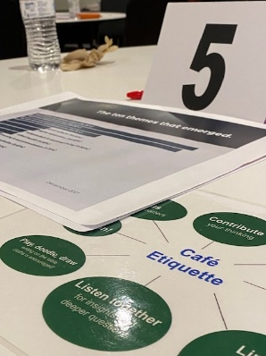The goal of the community workshop was to test results from the previous consultation activities and ensure that interpretation of the results resonated with the community, as well as to identify the criteria the community felt important to making decision about the site in the future.

The workshop was based on the [World Café model](http://www.theworldcafe.com/key-concepts-resources/world-cafe-method/) – creating an environment to encourage and support conversation, urging the sharing of broad perspectives and ideas, while capturing insights and shared learning and understanding.

Six worktables were organised across the broad space of the venue, creating an easy flow between tables and allowing conversations to be heard without disturbing adjacent tables. Each table was resourced with note paper, pens, two version of World Café etiquette, and key data from the previous consultations.

The session began with an overview of the consultation scope, process and a summary of consultation outcomes to date. Participants were encouraged to reflect on what they had heard from the introduction to assist focus on community outcomes before individual ideas.

The World Café was held in three segments with table participants being mixed with each round. This ensured that participants were exposed to a broad range of perspectives and given multiple opportunities to refine their thinking. This segment of the workshop was based on three key questions:

Round 1: What really matters about this site and must be retained? What is negotiable?

Round 2: What criteria will help us make a clear decision and recommendation from this meeting?

Round 3: What options should be explored against the criteria?

Participants were strongly encouraged to discuss each question before composing notes to share with the rest of the participants. Conversation was lively and respectful with a strong sense of collaboration and searching for win/win ideas rather than one idea over another.

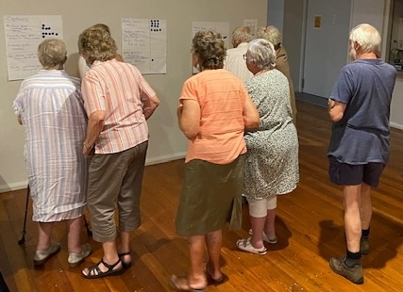At the conclusion of the World Café exercise, participants were asked to reflect on the options raised against the decision criteria they had collectively developed to prioritise ideas to take forward into a community vision for the site.

The event concluded with a presentation from Towong Shire Council explaining the next steps for the consultation outcomes and the process for advocating to influence future planning for the site.

Workshop outcomes

A number of passionate community members attended the workshop, and the world café model was successful in ensuring everyone had a chance to be heard. It also provided space to find alignment on key issues.

Discussion following a summary of outcomes from the survey and focus groups confirmed general confidence in the consultation undertaken to date, and appreciation that the consultation was led by a bipartisan organisation such as BRV.

Two distinct interest cohorts began the evening with a sense of opposition – those who identified the need for early childhood services and supports and those who represented the needs of aging community members. The initial survey outcomes discussion and world café activities resulted in a merging of ideas and agreement that not only was the site large enough to address both needs, but also that merging the two interest areas to create intergenerational services and activities would create even more community benefit.

As participants moved through the agenda, a sense of shared vision for the site became clear. Negotiables and non-negotiables in relation to the site were agreed. In summary, key negotiables were generally related to the arrangement of services and facilities on the site – as long as open green space was retained. Clearly non-negotiable to the community was that the site be retained for multi-purpose community use to benefit community across the life span. Respect for the heritage value of the old school building was also vital.

Following the world café exercise, participants agreed on a set of criteria against which to evaluate and prioritise ideas for the site. Agreed criteria:

* Community benefit – address a genuine community need
* 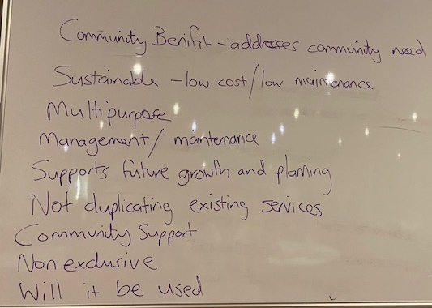Sustainable – realistic cost and ongoing maintenance requirements
* Multipurpose
* Management / maintenance
* Supports future growth and planning
* Does not duplicate existing services
* Supports community/people/families
* Non-exclusive – available and welcoming to all
* 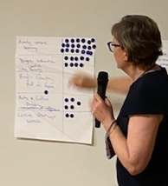Practical and realistic

The workshop concluded with an exercise to identify priority aspirations for the site. Participants were asked to consider all they had seen and heard over the evening including the prioritisation criteria and use one sticky dot to indicate the idea that they believed best met community ambitions for the site.

The workshop outcomes were summarised for participants by the facilitator who then invited Towong Shire Council to outline the next steps in taking the community vision for the site forward.

Future consultation

A number of questions were raised throughout the workshop which were outside the scope of discussion but relevant to ongoing planning. These included:

* Is the heritage building sound and able to be renovated successfully and within reasonable cost?
* Who would oversee the administration of the site?
* Who would be responsible for upkeep of the site?
* Who would own the site?
* Would the site be 100% community run or allow commercial business to be included?

It is recommended that these questions be addressed during future consultation as negotiations for the site progress.

Conclusion

The community workshop strongly confirmed that the Upper Murray community desires the disused Corryong Primary School site to be retained for multi-purpose community benefit, including community open green space with passive or active recreation and space for youth activities. The workshop also confirmed that the inclusion of early years’ service provision and higher education opportunities was highly desired by the community. The concept of including botanical garden aspects to the site were also strongly supported.

It was also clear that the community highly values the historical original school building on the site and would prefer the building to be retained. Further consultation is required to ascertain how much the community is prepared to surrender in terms of funding, volunteer time, and community responsibility to retain the building.

Feedback from the workshop indicates that the community feel heard in terms of their aspirations for the site to date. The community highly valued the impartiality of the workshop facilitation and expressed a strong desire to continue to be informed and involved in determining the future of the site.

# Appendix - World Café Raw Data

**Round 1** – **What really matters about this site and must be retained? What is negotiable?**

|  |  |
| --- | --- |
| **Must retain / Non Negotiable** | **Negotiable** |
| Heritage buildings | Buildings other than the old school building, toilets and Hub |
| Green oval | Portable buildings/demountable |
| Corner green (quiet space) | What goes where |
| Hub | Old Nariel School building |
| Toilets | Everything but the old school building |
| Don’t want to lose any of the area | Use of some of the oval |
| Open space | Access points |
| School building façade | Fence |
| Open green corner diagonal to Memorial Hall | The bank |
| Be inviting to people from the main street | Basketball courts |
| Parking areas | Toilet block location |
| Community minded | Who is going to pay to retain the building? |
| Old building | Roadside stops for the oval – that will pay for the school |
| Compatibility with heritage building |  |
| Allied health services to be for all generations |  |
| Community access |  |
| New buildings for child care |  |
| Upgrade the toilets |  |
| Basketball court |  |
| Donaldson Street parking |  |
| Bulldoze site other than Heritage building to accommodate many users |  |
| Indigenous Peoples – construct with Elders |  |
| Not another Uni |  |
| Lack of representation by Govt |  |
| Housing would degrade the site |  |
| Push for culture but local representation |  |
| Compliment existing offering |  |
| Economic viability |  |
| Multi use |  |
| Recommend / advocate vision for the site |  |
| Green space for walking, gardens and art work |  |
| At least 50% open space |  |
| Trees |  |

**Round 2: What criteria will help us make a clear decision and recommendation from this meeting?**

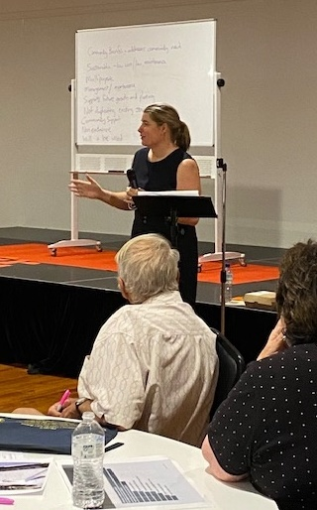What most or majority of people want

Consensus

Community benefit

What benefits the community the most

Fills an area of need

Overarching community run board to coordinate and provide oversight

Heritage value

Multipurpose

Cost

Sustainability

Not cost – the sky is the limit

Community survey has broadest consultation

Self sustaining, low cost, low maintenance

Will it be used?

Non-discriminatory (accessible and of benefit to all)

Not duplicate existing services

Supports future planning and growth

Long term benefits to community as a whole

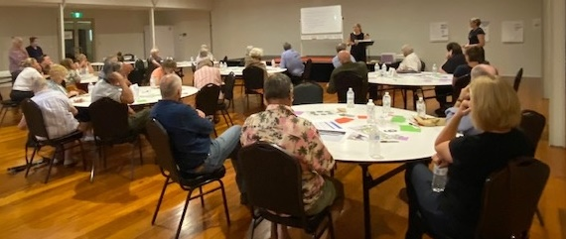

**Round 3: What options should be explored against the criteria?**

Heritage building

Art and culture

Oval – use as overnight location for caravanners – maximum 2 nights stay

Buildings/spaces for start ups to lease

Maternal Health and Child Care

Youth activities

Walking/bike path

Skate park

Passive outdoor setting – botanical garden, therapeutic garden

Community recreation space for all ages

Early education and after school care

Education centre for water catchment, learn about the Upper Murray,

Combined early years and seniors centre

Quiet area and child friend area

Accessible public amenities

Use service road for long vehicle parking

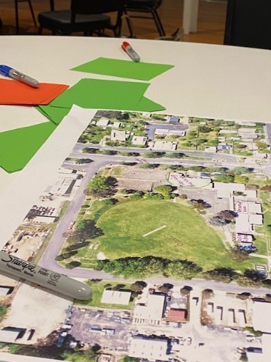Space for visiting agencies

Community gathering space

Higher education

High Country Hall of Fame

Agricultural college – tertiary level

One room museum for local education

Outdoor exercise equipment

Running tracks

Childhood special needs eg speech therapy

Mini children’s fun park

Informal sports centre e.g. backyard cricket

Gut interior of old school to create user friendly space

**Prioritisation exercise**

|  |  |
| --- | --- |
| **Option** | **Number of votes (sticky dots)** |
| Community open space – passive or active recreation | 11 |
| Youth activities space including a skate park | 11 |
| Multi use space   * Community gathering * Agencies | 10 |
| Early years learning | 9 |
| Higher education centre – Agriculture tertiary education | 9 |
| Botanical garden | 8 |
| Arts and Culture building   * Interpretation of water importance | 5 |
| Accessible public amenities | 5 |
| Short term caravan accommodation space | 4 |
| Local start up space | 2 |
| Independent Living | 2 |
| Use service road for long vehicle parking | 1 |
| High Country Hall of Fame | 1 |

